Faculdade de Engenharia da Universidade Do Porto

Mestrado Integrado em Engenharia Informática e Computação

Engenharia de Software

T3 – Software Development in Practice - Jest

*Alunos:*

João Gama Amaral

João Nuno Ferreira

Pedro Galvão

15 de Novembro, 2018

Índice:

Issue #6830

* Documentation…………………………………………………………………...3
* Requirements…………………………………………………………………….3
* Source Code Files………………………………………………………………..4
* System Architecture……………………………………………………………..4
* Design of the fix…………………………………………………………………6
* Fix Source Code…………………………………………………………………8
* Validate the fix…………………………………………………………………..9
* Submission of the fix…………………………………………………………...10

Issue #5730

* Documentation………………………………………………………………..11
* Requirements…………………………………………………………………11
* Source Code Files…………………………………………………………….13
* System Architecture…………………………………………………………..14
* Design of the fix………………………………………………………………15
* Fix Source Code………………………………………………………………16
* Validate the fix………………………………………………………………..16
* Submission of the fix………………………………………………………….16

**Issue Documentation**

**Issue #6830**: iterables and **toHaveBeenCalledWith** result in **RangeError**: Maximum call stack size exceeded.

If toHaveBeenCalledWith is used with an iterable, **RangeError: Maximum call stack size exceeded** will be thrown.

Jest is a desktop application that is used by Facebook to test all JavaScript code including React applications.

Version in package.json: “jest”: “^23.5.0”,.

**Use case:**

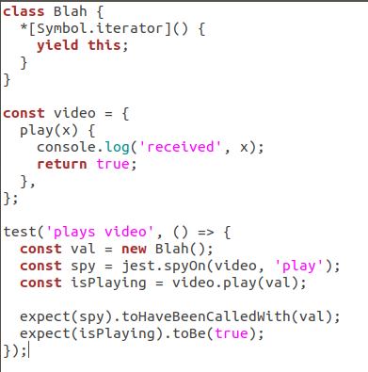The issue consists in the usage of a specific iterator that generates an error message when we try to make tests with it. The expected behavior is for the test to pass. We can check it by declaring a variable with the specific iterator and then call functions defined in Jest to check it. Here is an example to reproduce the behavior:

First, a class that uses the iterator (*[Symbol.iterator]()) is created. Then a function to be tested and the test itself are created. It can be checked that on the test function it is created a variable using the class Blah, this guarantees that the specific iterator is used. In the end the function toHaveBeenCalledWith is used, using as an argument the variable that was first declared. This should show successful tests but instead the tests fail.

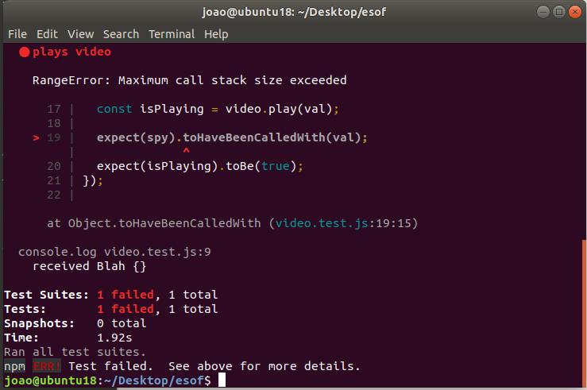Results:

Somehow the class used is generating something too big, therefore, calling Maximum call stack size exceeded. In the reproduction of the error it is called a **console.log** to verify the value passed to the Jest test functions, and here it is printed “received Blah {}”, which is not an actual value.

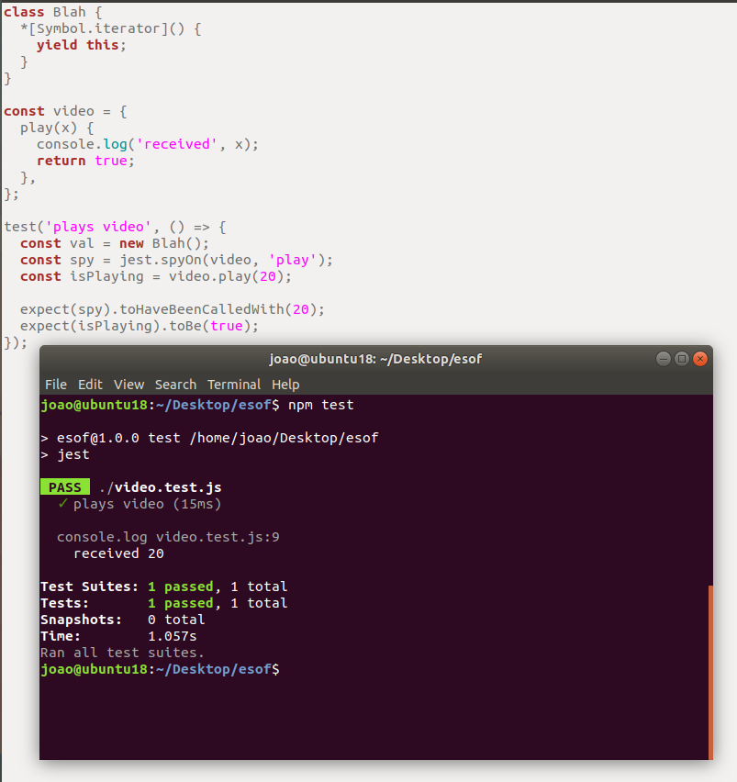In order to verify that the iterator was the actual cause of the issue, the value called on the test functions was changed to an integer. As expected, the tests succeeded. This leads to the conclusion that Jest does not have the proper code to receive and deal with this specific iterator.

**Explanation of the iterator:**

*[Symbol.iterator] () creates a custom iterator for Blah object. But written this way, the iterator never ends, so it is like a loop without an end-condition. **Yield.this** defines the value to return from the generator function via the iterator protocol, returning the optional value passed to the gen*erator’s next () method.

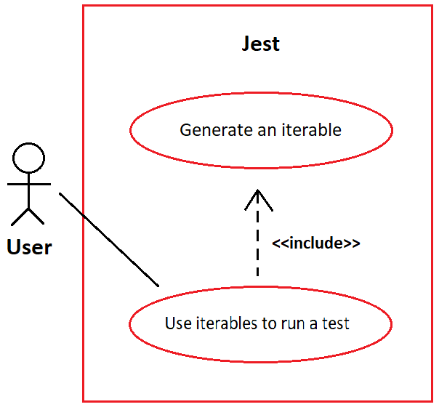**Use case:**

**User story:**

As a programmer for Jest I want an alternative for an iterable that is so big that it ends up calling the Maximum Stack Size Error, so that the test is able to pass.

**Source Code Files**

Files that are directly related to the issue:

1. jest/packages/expect/src/spyMatchers.js
2. jest/packages/expect/src/utils.js

The file number 1 is responsible for creating a “**spyMatcher**” that will test the function with the value that was passed to “toHaveBeenCalledWith”.

The file number 2 is used in the first file. The first file imports an “iterableEquality” from the second file. This “**iterableEquality**” is responsible for handling the values passed to the test functions like “**toHaveBeenCalledWith**”.

Files that are indirectly related to the issue:

1. jest/packages/expect/src/jasmineUtils.js

The file number 1 is indirectly related to the issue, that is because it contains a function “equals” that is used in “jest/packages/except/src/utils.js” to help handling the iterable.

**System architecture**

After a lot of research in this repository we were able to construct the system architecture to help localize the issues we are working on.

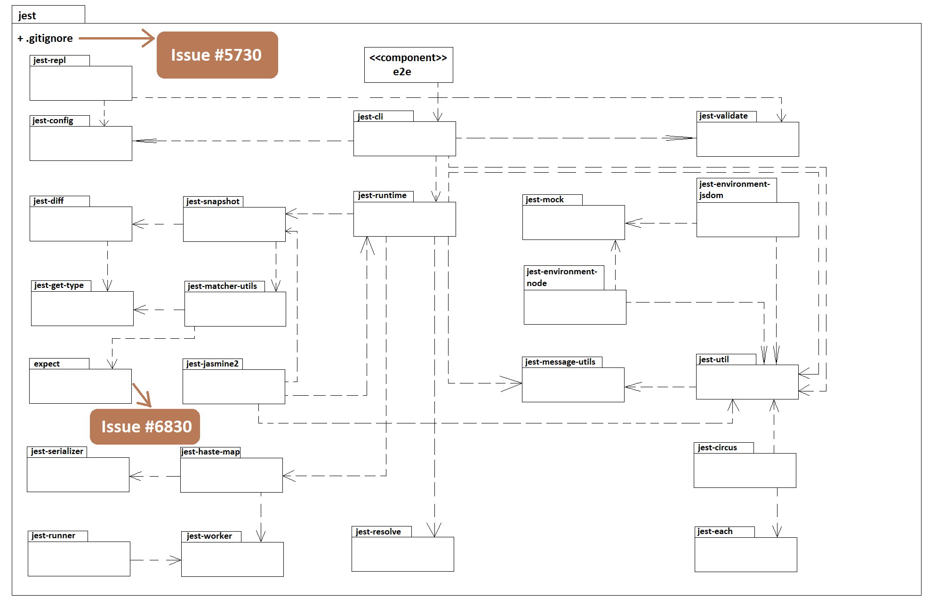This issue in particular is related to the component **“expect”** marked in the package diagram bellow:

**Design of the fix:**

In order to fix the issue it won’t be necessary to add any aditional files or even classes. To fix it, it will be needed to change some cycles adding more conditions to verify the state of the iterable when used. In other words, the code of the defined functions needs to be changed se that it can handle the iterables without creating an infinite loop.

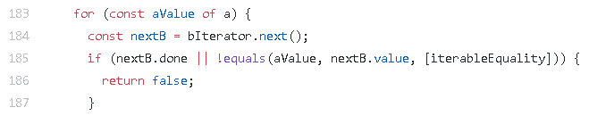The values of the iterable might recurse forever here:

**jest/packages/expect/src/utils.js**

To show the fixes that will be made, we organized the design of the fix in this package diagram:

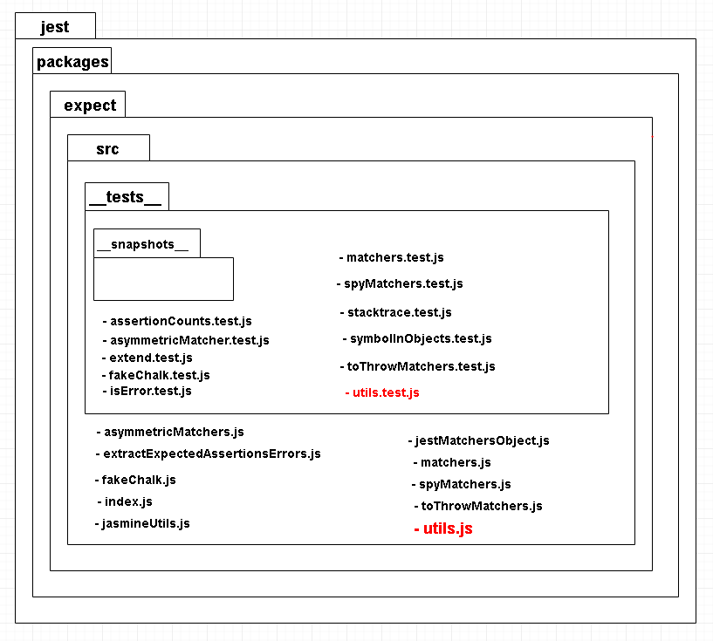

The fix will be focused on changing the files **jest/packages/expect/src/utils.js** and **jest/packages/expect/src/__tests__/utils.test.js**. On the **utils.js** file it is essential to change the cycle “for” referred above. The change must focus on controlling some variable that might be letting the cycle iterate infinitely.

On the **utils.test.js** we must had a single test to check if the changes done on **utils.js** worked properly.

**Fix Source Code:**

The main problem on the code that was being used by Jest was the fact that it wasn’t prepared to handle Iterators. The main idea for this fix was to find a way to control the amount of recursive calls that were being made when using Iterators.

The if condition in line 185 was calling the function **equals** too many times. To fix this it was created a global variable called **count** that incremented every iteration of the cycle for. It was also created another global variable called **iterableController** which is responsible for stopping the cycle and can be defined as any number. For tests we defined it with the number 100.

**Alterations**:

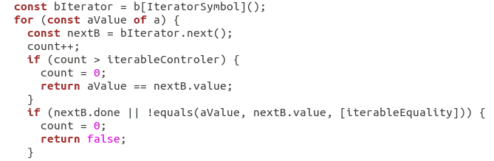

As mentioned, once **count** is bigger than **iterableControler**, we reset the value of **count** and return the comparison between **aValue** and **nextB.value**. A local variable is unable to count the iterations because the infinite loop was being caused by the call to iterableEquality inside the cycle, so a local variable would be set to 0 again every time the function was called. The best idea was to declare this count variable as a global variable, initialized outside the function and being incremented just before the “if” condition.

In order to find out if the solution developed was working correctly it was tested using a test that other contributor recommended.

**Results:**

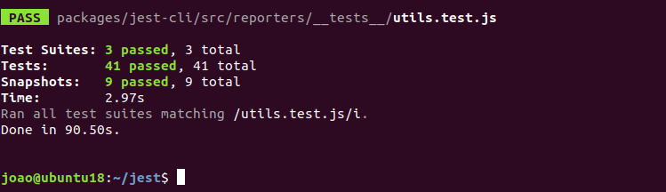

The results were what we expected, the test passed since it had a controller for the Iterable, not letting the program making recursive calls so many times and ending up in Error.

**Validate the fix:**

For the fix validation we used a test that was proposed by another contributor, and a test developed by us, based on the design of the other test.

**First test:**

The test consists in creating a class that creates an Iterable. A constant variable is created using a new object from the created class. Then we call the function **expect(iterableEquality(val,val)).toBe(true)** so that we can see the results of our code change.

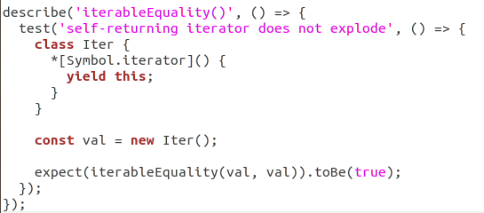~

When running this test with the code changes applied the results are:

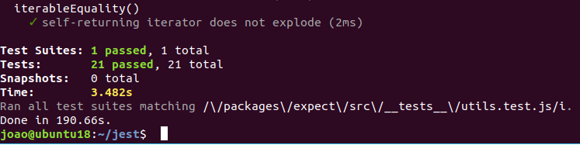

For this test we defined the limit of iterations with 100, but the value can be changed as the programmer wants to.

**Test cases:**

|  |  |  |  |
| --- | --- | --- | --- |
| **Test case #** | **Description** | **Inputs** | **Expected output** |
| **1** | Simple declaration of a Symbol.Iterator as a class. | **class Iter** | Test passes. |
| **2** | Declaration of a symbol iterator as a class but now yielding 1000 times a value. | **class Iter** | Test passes. |

**Submission of the fix:**

The submission of the fix was made doing a pull request. For the submission to be approved it needed to pass in 9 checks. Our submission passed 8 checks and failed one:

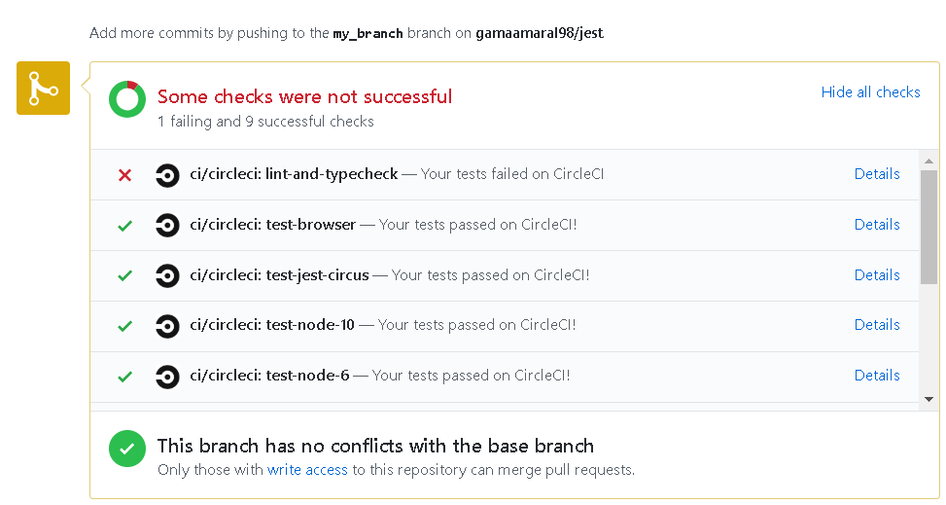

As a result, the submission wasn’t successful. The issue wasn’t closed by any contributor outside the group, the issue remained the same since delivery #1 and no other issues were created when trying to correct this issue.

**Issue Documentation**

**Issue #5730**: Support dynamically detecting changes when *.gitignore* is updated

A certain repository has a *.gitignore* file in it. This type of file specifies intentionally untracked files that Git should ignore. Each line in a *.gitignore* identifies a pattern that must be disregarded.

If a *\*.js* is selected, then all changes in JavaScript (*.js*) files will not be taken into account. Besides this, Jest tests are coded in TypeScript files (*.ts*). The problem consists in the fact that when editing *.ts*, although Jest notices the file changes, it does not run the tests. But, when removing *\*.js* from the *.gitignore* the Jest runs those same tests.

**Requirements**

The case described on the issue documentation, implies that the users trying to fix the problem install and use either the suggested *Yarn* and *NPM* or any other dependency managers (for example, *IED*, *PNPM* or *NPMD*) that Jest can work with. These programs that are responsible for controlling the packages will be used to the user be able test.

**Example**

As said before, Jest is a robust framework, so it will be used along with *Yarn*/*NPM* for **package** and **dependency** management.

To test you must:

1. Install the *NPM*:

C:\Users\User\Desktop\download.png

1. 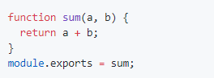Create a *sum.js* file, with the following code:
2. 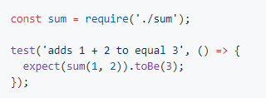 Create a *sum.test.js* file, with the following code:
3. 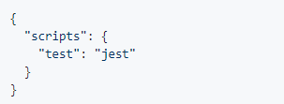Modify the *package.json* file, changing the code inside the *“scripts”* curly brackets to *“"test": "jest"”*:
4. downloadCreate a file named *.gitignore*, that will be automatically hidden, with:

After the whole preparation, the user must keep running the *“tsc –watch”* and run *“jest –watch”*. Edit the *sum.test.js* and observe if the Jest notices the file change and if it runs any tests. Finally, the user should try removing the *“*.js”*, and repeat the previous process. The results must be the same as the ones obtained by this GitHub user:

<https://user-images.githubusercontent.com/1370842/45393212-dec1e000-b665-11e8-988f-b8e7e1fea459.gif>

**Use case:**

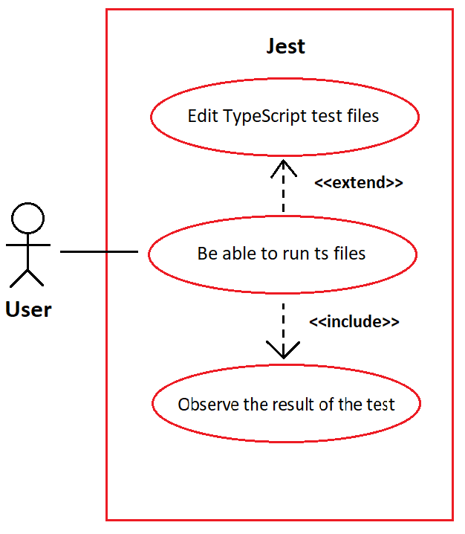

**User story:**

As a programmer for Jest I want to be able to test the TypeScript test files, so that Jest is able to run those same files in which some tests to the code are made.

**Source Code Files**

Taking into account that the only files that are affected by this problem are the TypeScript tests, we can narrow them down to:

1. *jest/e2e/coverage-remapping/__tests__/covered-test.ts*, which requires the file *jest/e2e/coverage-remapping/covered.ts*
2. *jest/e2e/typescript-coverage/__tests__/covered-test.ts*, which requires the file *jest/e2e/ typescript-coverage /covered.ts*
3. *jest/examples/typescript/__tests__/sum-test.ts*, which requires the files *jest/examples/typescript/sum.js* and *jest/examples/typescript/sum.ts*
4. *jest/examples/typescript/__tests__/sub-test.ts*, which requires the same files in the previous point.

Both files number 1 and 4 are responsible for testing whether the result of a difference between two numbers is right or not in TypeScript files.

The second file is similar to the previous one, but this time tests a sum, also in a TypeScript file.

Again, the third test is related to the test of sums with the difference that it tests in both JavaScript and TypeScript.

Finally, the *.gitignore* files are the ones that affect the *test.ts*, so we may also mention:

1. *jest/.gitignore*

* *jest/e2e/coverage-report/.gitignore*
* *jest/examples/react-native/.gitignore*

The last two files may be ignored during the solving of this issue, since the solution for both of them must be exactly the same as the one in the first *.gitignore*, which is more general.

**System architecture**

The system architecture is exactly the same as the previous issue, but this time this issue is related to the component gitignore, marked in the package diagram bellow:



**Design of the fix**

Just like the previous issue, we believe that the solution for this problem does not involve the creation of extra files or classes. In order to solve this particular issue, we must only change the *.gitignore* file. It is possible that the fix might be involved in adding an additional condition to this file.

Package diagram:

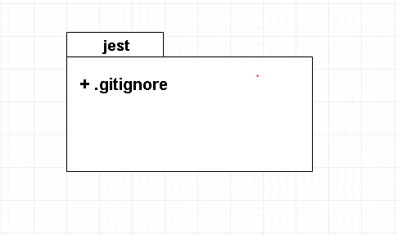

We have thought of changing this *.gitignore* in a way that keeps allowing Jest to ignore the changes in *.js* files, but not ignore the *.ts* or the *.test.ts* files.

**Fix source code**

As the issue main problem was around having *.js on the gitignore file we thought about adding a feature that would let the test files get through the gitignore so the tests could run.

In order to fix the issue we added a line of code to the gitignore file:

**!*.test.js**

The alteration should allow the test files generated by the typescript files to run and complete the unit tests.

**Validate the fix**

In order to validate our fix it was needed to try this change with tests as long as they had the typescript extension. One of the tests used was given by another contributor.

**Test:**

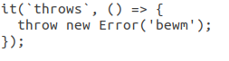

The unit tests don’t need to have any level of complexity since the issue is only about the test running or not, with or without the *.js line in the gitignore file.

**Submission of the fix**

The submission of the fix couldn’t be done, neither the validation. This happened because the reproduction of the fix doesn’t work anymore. The issue reproduction should be made by running this:

1. tsc –watch;
2. jest –watch;
3. Edit the foo.test.ts and observe that jest notices the file change, but doesn’t run tests;
4. Remove *.js from .gitignore;
5. Edit foo.test.ts again, and observe that jest runs the test;

The problem is: when the command **jest –watch** is executed, it shows an error message stopping us from testing any type of changes made in the code.

**Wrap-up:**

Student 1 (João Nuno Ferreira): 33,33 %

Student 2 (João Gama Amaral): 33,33 %

Student 3 (Pedro Galvão): 33,33 %

In the end, the work for T3 delivery was evenly divided, we all worked as a team and did all the expected.